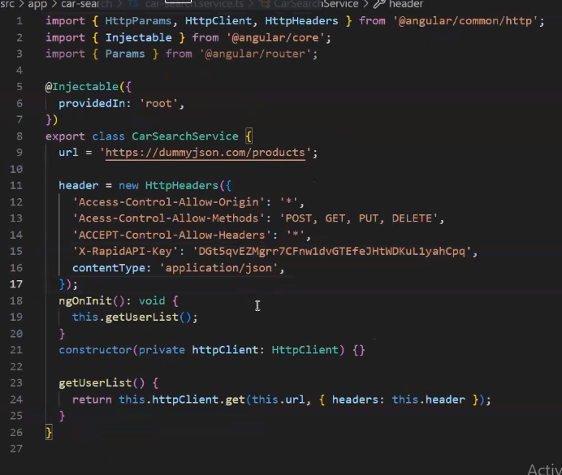

To create a new module,

Ng g m <module-name>